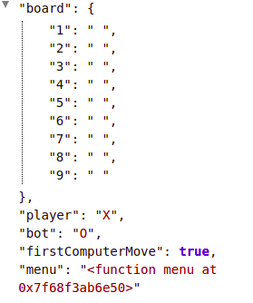
<- 1 st step

------------------------
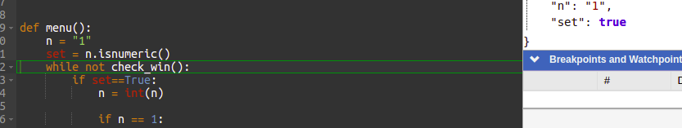
While not checkwin - > will go through all the conditions of the check win -> for now our values are empty so it will return false and

flow will continue going inside while loop

--------------------
As player is called first and player=x

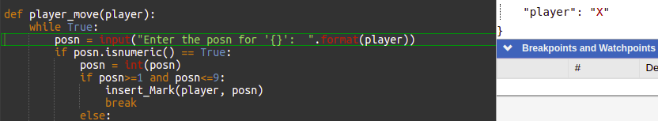
If the posn is passed 1
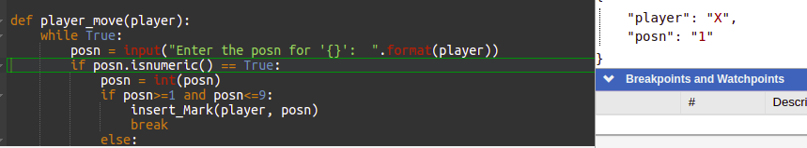

it will dive into if loop
If everything goes well it will call insert mark method to append the player[x] at the given posn for here its 1

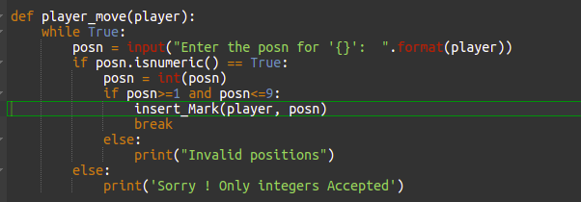

But befoore appending mark at the given postion it cheks whether the given postion is free or not
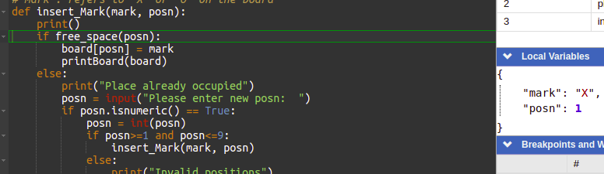

free_space method will check whether the passed position is Empty or not
If its empty it will return TRUE to insert_Mark method(x,1)
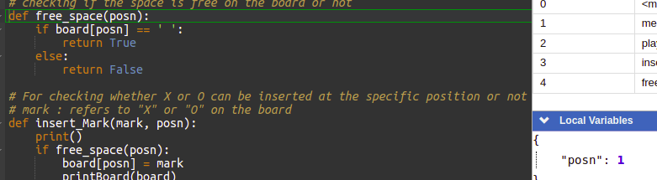

this will assign the mark [x] at the posn 1 in the board
Hence x will be appended in the dict with key 1
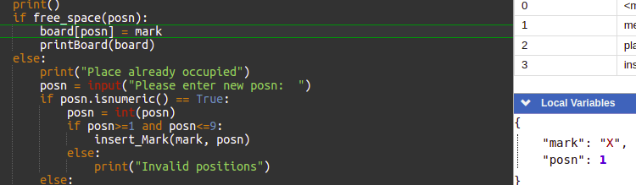
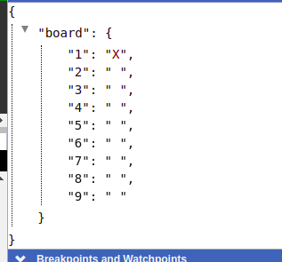

< Like this

After inserting the mark at the given posn the if loop will break
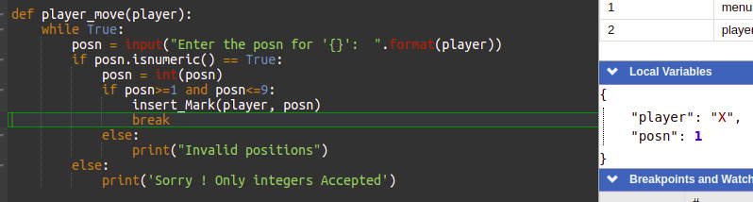
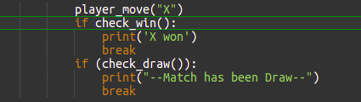
and check for chek will condn

as no one is gonna win it will return false
and check for check draw

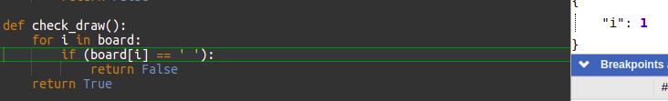
this is gonna return false and here the value of i is 1 and will increment to 2 and return false

Aftert that player 0 will get chance to select a position
=> suppose we select the used position
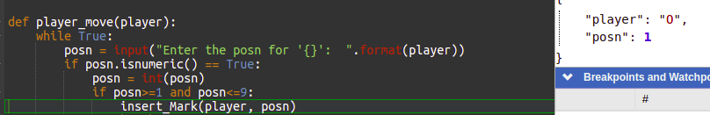

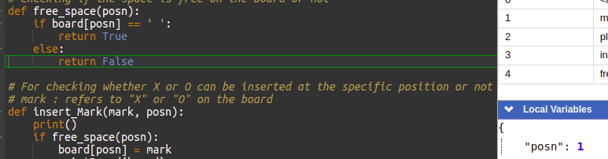
as THE POSTION 1 IS ALREADY occupied it will return false
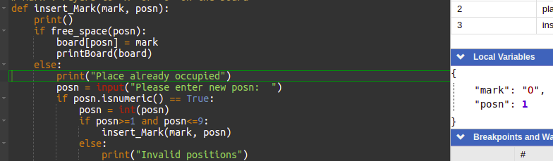
this will jump to else part and print “place...”
and take a new posn

if the posn is not between 1 to 9 it will return invalid posn
and if the posn is enterd correctly it will again call the insert mark method and do the same stuff again
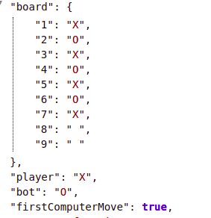
----------
At last when the player is winning the check will wil return True
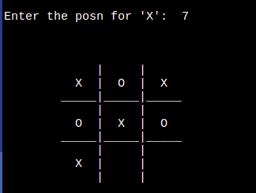
and program will print x won as it was his when he was won

